User Social Integration

# Social Media Integration

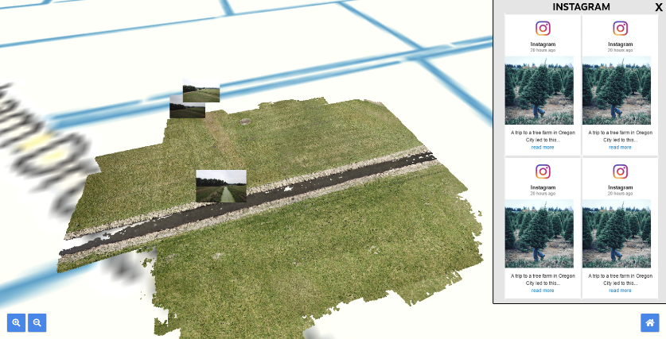A system could be implemented to the ARTSTATION project to allow for users to post to a hashtag on social media via sites such as Instagram or Twitter. Upon posting to this hashtag, their post will then appear within the application in a side panel, a great way to show off activity at the site and share stories from people that visit in person.

Due to the potential of users posting explicit or unrelated content to this hashtag, we imagine a system where posts that show on the site will be approved by a moderator. For example, on Twitter, an account would be setup that explores the hashtag and retweets any appropriate content, upon being retweeted the application then knows it is safe to show.

A limitation of the social media approach is that we are unable to gather precise GPS data from posts, which we could potentially implement in a custom solution. For this reason, the suggestion of a scrolling sidebar was put forward, which would show all recent posts relating to the entire location rather than specific points on it.

# Custom Solution

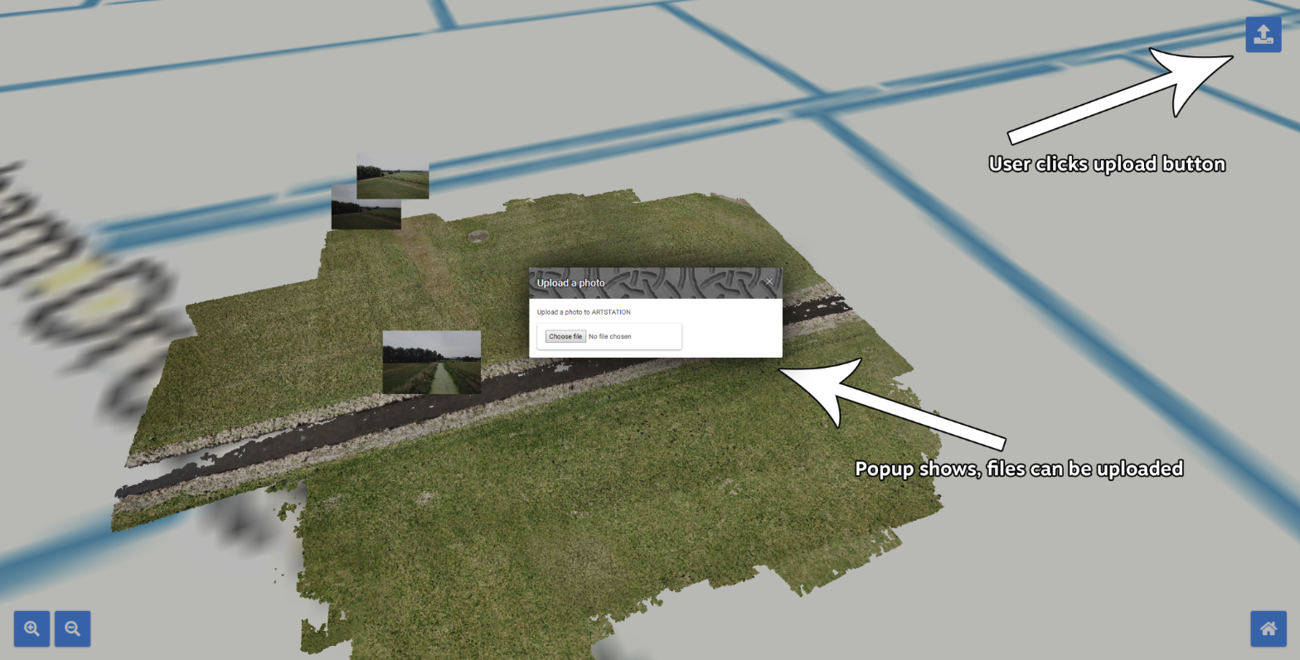A custom solution would allow for much more customisation, for example, the ability to add GPS positioning similar to how Google Maps allows users to upload their own 360 degree images to the platform.

Although providing extra customisation, a custom solution does also have its drawbacks, that being that again it would require a human moderator, require a server with larger file space and PHP support, and also require significantly more development time than a social media integration.